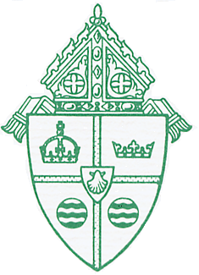 | Communications Office  DIOCESE OF BROOKLYN  1712 10th Avenue, Brooklyn, New York 11215  718.499.9705 x636 • Fax: 718.499.2406

RETURNING TO MASS
FREQUENTLY ASKED QUESTIONS

When can we return to Church for Mass?
Celebration of Daily Mass can begin on Monday, June 29, 2020, with COVID-19 safety protocols that require the Church to be filled at 25% capacity.
Celebration of Sunday Mass can begin on Saturday evening, July 4, 2020, and Sunday, July 5, 2020, with the same restrictions limiting church capacity to 25%.

What do I need to do in order to go to Church and attend Mass?
COVID-19 safety protocols require that everyone coming to Church must be wearing a mask, and wear the mask for the duration of the Mass. We encourage parishioners to take their temperatures before leaving for Church, if possible, and to wash hands before leaving their homes.

When I arrive at the Church, what can I expect?
You will find pews spaced out so the faithful can sit six feet apart. Families from the same household can sit together. There will be no entrance procession, no exchange of the sign of peace, no holding of hands at the Lord’s Prayer. Music will be limited to an organist and a cantor using social distancing. There will be no missals or worship aids available.

How will communion be distributed?
The communicant should come before the priest or Minister of Communion with their mask on and observing a six-foot distance from the person in front of them. As you approach, accept the Holy Eucharist in your hand and then step to the side, six feet away, lower your mask and consume the Host immediately. Then replace your mask and return to your seat. No Precious Blood will be distributed to the faithful at this time.

How will I be able to give my weekly donation?
There will be no traditional collection passed around with a basket or box. There should be a single offertory basket or box where people can place donations. We highly encourage parishioners, though, to use e-giving. Check with your parish to enroll.
How do I exit the Church?
There will be no recessional procession or greeting of parishioners as they depart. Remember to maintain six feet of distance when you are exiting the Church and follow the direction of ushers.

What is my parish doing to keep me safe?
Your parish is regularly disinfecting the Church. Priests will clean their hands before and sometimes during the Mass if there is any incidental contact during Holy Communion.

