May 31, 2020

CORL Statement on the Death of George Floyd

The Book of Ecclesiastes teaches us, “There is a time to be silent and a time to speak out.” We of different faiths cannot remain silent after we watched the shattering video of a police officer keeping his knee on the neck of George Floyd who was crying out “I can’t breathe.” Such inhumane treatment of another human being requires a collective response from all people of conscience. The pursuit of justice is a fundamental tenet of our respective religious traditions, and thus we stand together to declare that all life is sacred, and all people are equal before the law in a democratic society.

We respect those who want to honor George Floyd’s memory with peaceful protest against the horror, evil, and sin that is racism. We also support the members of Floyd’s family who said, in part, “We cannot endanger each other as we respond to the necessary urge to raise our voices in unison and in outrage. Looting and violence distract from the strength of our collective voice.”

We often speak of “thoughts and prayers.” We will offer our many prayers of healing, but we need not only serious thoughts but also firm action as we work together with all members of our community to find that critical cure for human hatred.

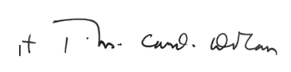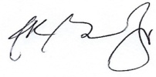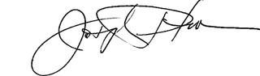
Cardinal Timothy Dolan Rev. Dr. A.R. Bernard, Sr. Rabbi Joseph Potasnik
Chair President Vice President

