Accessing Diocese of Brooklyn Android Mobile App
from Google Play
Users with Android mobile phones and other devices can download the Diocese of Brooklyn mobile app from the Google Play store. This app allows users to log in and access their online courses.
To locate and install the Diocese of Brooklyn mobile app in the Google Play store, follow the instructions listed below.
- From your device, visit the Google Play store
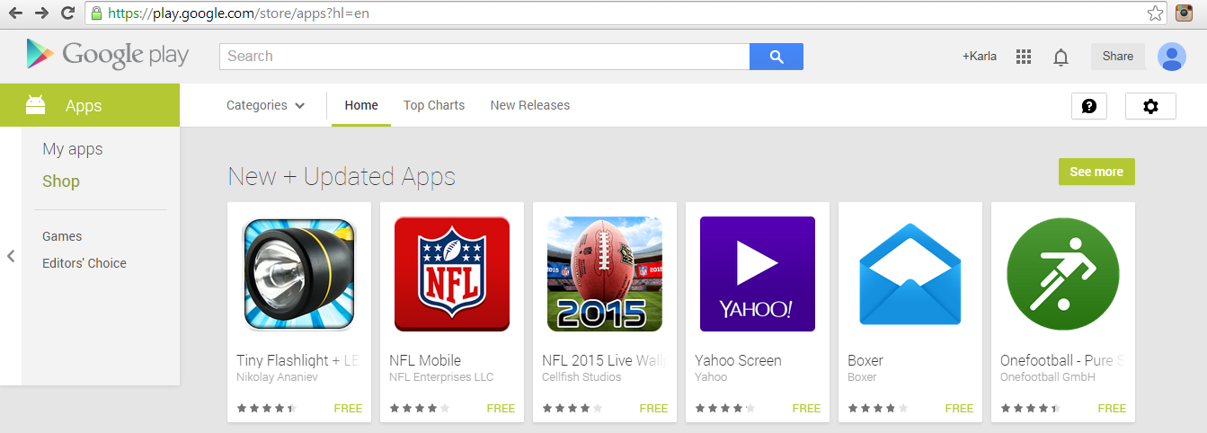
- In the Search field at the top of the window, type in “Diocese of Brooklyn” as shown in red box (or dark outline at the top of the image if printed) in the figure below, and click on the magnifying glass at the end of the box to search for the app.
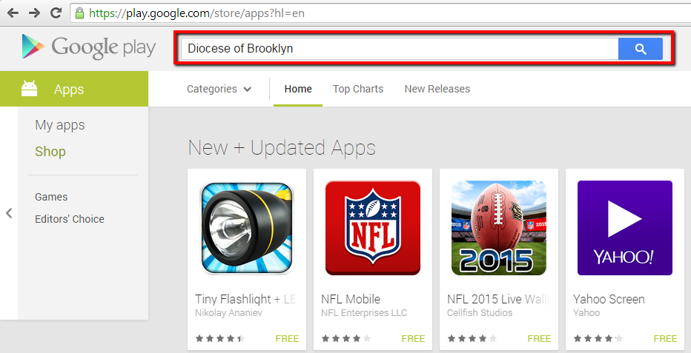

- Locate the Diocese of Brooklyn app as shown below in the red box (or dark outlined box if printed), and click on the image.
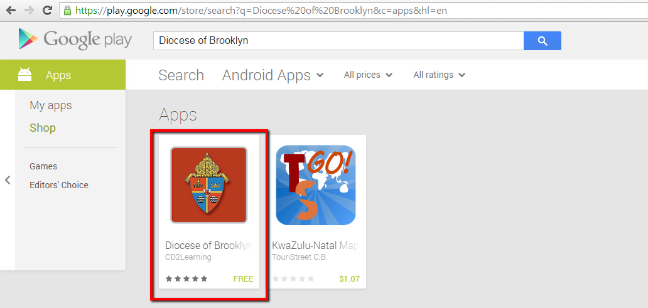
- You will then be prompted to install the app on your device. Do this by clicking on the <Install> button in the red box (or dark outlined box if printed).
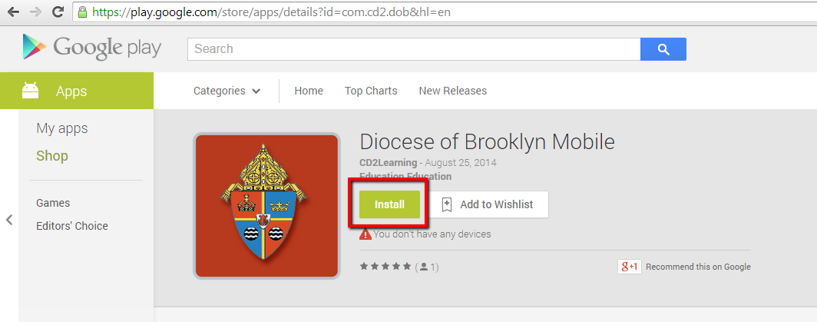
- Once the app is installed on your Android device, you will tap or click the Diocese of Brooklyn icon on your desktop.
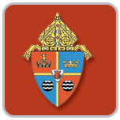
- Clicking the icon will launch the app. You will be prompted to enter your username and password. This is the same as you use on the website on your computer.
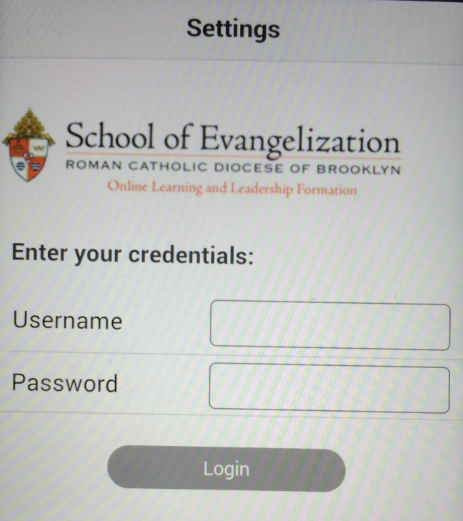
- Once you have successfully logged into the app, tap or click on the <Learn> button as shown below.
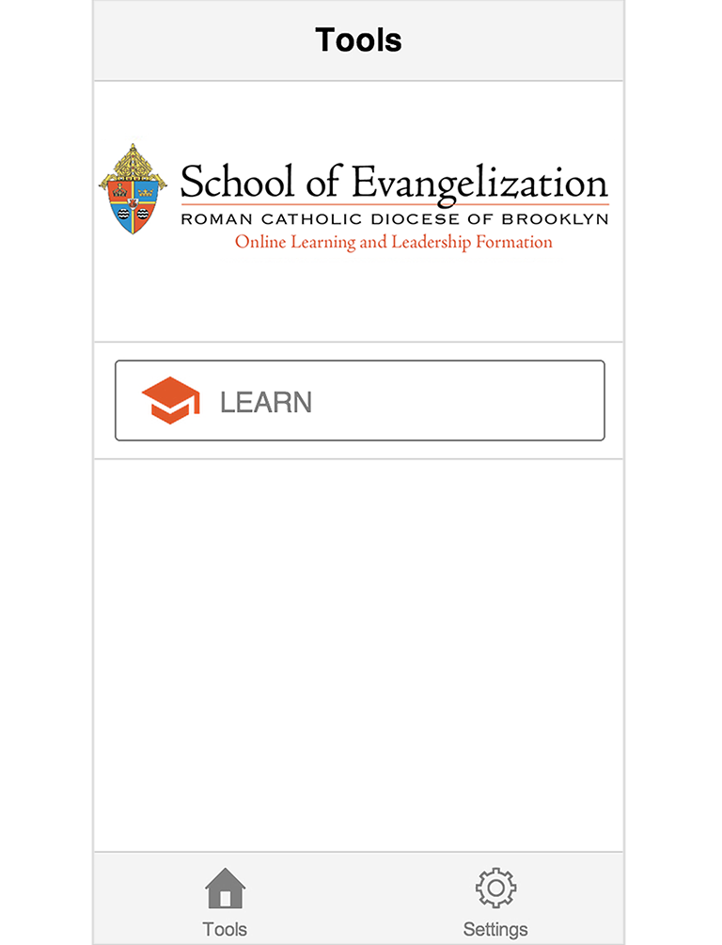
- Choose the course you want from the list as shown below by tapping or clicking on the title.
- This is a sample lesson page. Use the navigation buttons to advance to the next page or return to previous ones.

